
SCHOOL OF COMPUTING AND INFORMATION TECHNOLOGY

A Project Report
on
ENERGY-AWARE TRAJECTORY CONSTRUCTION FOR A MOBILE SINK IN WIRELESS SENSOR NETWORKS
Submitted in fulfillment of the requirements for the award of the Degree of

Bachelor of Technology

Submitted by

Karthik K Pagnis- R20EA076
Hallada Manoj- R20EA073
Ivan Benedict Rowe- R20EA074
D Sachin- R20EA069

Under the guidance of

Prof. M Mallikarjuna

2024

Rukmini Knowledge Park, Kattigenahalli, Yelahanka, Bengaluru-560064
www.reva.edu.in
DECLARATION

We, Mr. Karthik K Pagnis, Mr. Hallada Manoj, Mr. D Sachin, Mr. Ivan Benedict Rowe students of Bachelor of Technology, belong in to School of Computing and Information Technology, REVA University, declare that this Project Report / Dissertation entitled “ENERGY-AWARE TRAJECTORY CONSTRUCTION FOR A MOBILE SINK IN WIRELESS SENSOR NETWORKS” is the result the of project / dissertation work done by us under the supervision of Prof. M Mallikarjuna and at School of Computing and Information Technology, REVA University.

We are submitting this Project Report / Dissertation in partial fulfillment of the requirements for the award of the degree of Bachelor of Engineering in Computing and Information Technology by the REVA University, Bangalore during the academic year 2024.

We declare that this project report has been tested for plagiarism and has passed the plagiarism test with a similarity score less than 20% and it satisfies the academic requirements in respect of Project work prescribed for the said Degree.

We further declare that this project / dissertation report or any part of it has not been submitted for award of any other Degree / Diploma of this University or any other University/ Institution.

Signature of the candidates with dates

Certified that this project work submitted by Karthik K Pagnis, Hallada Manoj, D Sachin, Ivan Benedict Rowe has been carried out under my / our guidance and the declaration made by the candidate is true to the best of my knowledge.

Signature of Guide | Signature of HOD | Signature of Director of School
Date: ……………. | Date: ……………. | Date: …………….
 |  | Official Seal of the School



SCHOOL OF COMPUTER SCIENCE AND ENGINEERING.

CERTIFICATE

Certified that the project work entitled “ENERGY-AWARE TRAJECTORY CONSTRUCTION FOR A MOBILE SINK IN WIRELESS SENSOR NETWORKS” carried out under my / our guidance by Karthik K Pagnis(R20EA076), Hallada Manoj(R20EA073), D Sachin (R20EA069), Ivan Benedict Rowe (R20EA074), are bonafide students of REVA University during the academic year 2024, are submitting the project report in partial fulfillment for the award of Bachelor of Technology in Computing and Information Technology during the academic year 2024. The project report has been tested for plagiarism and has passed the plagiarism test with a similarity score less than 20%. The project report has been approved as it satisfies the academic requirements in respect of Project work prescribed for the said Degree.

Signature with date | Signature with date | Signature with date
Prof. M Mallikarjuna | Dr. Mallikarjun M Kodabagi | Dr. Mallikarjun M Kodabagi
Guide | HOD | Director

External Examiners
Name of the Examiner with affiliation Signature with Date
1.
2.

ACKNOWLEDGEMENT
Any given task achieved is never the result of the efforts of a single individual. There are always a bunch of people who play an instrumental role leading a task to its completion. Our joy at having successfully finished our major project work would be incomplete without thanking everyone who helped us out along the way. We would like to express our sense of gratitude to our REVA University for providing us the means of attaining our most cherished goal.
We would like to thank our Hon’ble Chancellor, Dr. P. Shyama Raju and Hon’ble Vice-Chancellor (I/C), Dr. N. Ramesh for their immense support towards students to showcase innovative ideas.
We express thanks to our respected Director, Dr. Mallikarjun M Kodabagi and our HOD, Dr. Aruna Kumar B for providing us with a highly conducive environment and encouraging the growth and creativity of each and every student. We would also like to offer our sincere gratitude to our Project Coordinator Prof. Pratap M. S. for the numerous learning opportunities that have been provided.
We would like to take this opportunity to express our gratitude to our Project Guide, M Mallikarjuna, for continuously supporting and guiding us in our every endeavor as well for taking a keen and active interest in the progress of every phase of our Project. Thank you for providing us with the necessary input and suggestions for advancing with our Project work. We deeply appreciate the wise guidance that sir has provided.
Finally, we would like to extend our sincere thanks to all the faculty members, staff from the School of Computing and Information Technology.
List of Group Members:
Karthik K Pagnis (R20EA076)
Hallada Manoj (R20EA073)
D Sachin (R20EA069)
Ivan Benedict Rowe (R20EA074)

Contents

List of tables with titles and page references i
List of illustrations / Screen Shots if any, with titles and page references. ii
List of Symbols, Abbreviation of Nomenclature iii
Abstract iv
- Introduction 1
- Literature Survey 2
- Positioning 4
  - Problem statement 4
  - Product position statement 4
- Project overview 5
  - Objectives 5
  - Goals 6
- Project Scope 7
- Methodology 8
- Modules identified 13
- Project Implementation. 16
  - Architectural Design 16
  - Class Diagram 18
  - Sequence Diagram 24
  - Description of Technology Used 28
- Findings / Results of Analysis 29
- Cost of the Project 33
- Conclusions 34
- Project Limitations and Future Enhancements 35
- References 36

List of tables

Table No. | Description of table | Page no.
1 | Project Timeline | 4
2 | Cost of the Project | 29

List of Illustrations

Illustration No. | Description of Illustration | Page no.
1 | Design for path construction algorithm | 15
2 | Design for minimum number of mobile sink selection algorithm. | 16
3 | Flowchart of algorithm for collection point (CP) selection. | 17
4 | Flowchart of algorithm for Path Construction. | 18
5 | Flowchart of algorithm for Minimum Number of Mobile Sinks Selection. | 19
6 | Flowchart of Clustering Algorithm. | 20
7 | Flowchart of Euler Path Algorithm. | 21
8 | Flowchart of Perfect Matching Algorithm | 22

List of Figures
Fig No. | Description of Figure | Page No.
1 | Collection point selection algorithm | 9
2 | Path Construction algorithm | 10
3 | Minimum Number of mobile sinks calculation algorithm, clustering algorithm, Euler Path Algorithm and Perfect Matching Algorithm. | 12
4 | The output of the collection point selection algorithm | 23
5 | The output of the path construction algorithm | 23
6 | Graph of nodes and output of clustering algorithm | 24
7 | Minimum Spanning Tree of First Cluster and it’s Euler Path | 25
8 | Minimum Spanning Tree of second Cluster and it’s Euler Path | 26
9 | Minimum Spanning Tree of Third Cluster and it’s Euler Path | 27
10 | Comparison of Travel Distances for different Algorithms | 30
11 | Comparison of Travel Times for Different Algorithms | 30
12 | Comparison of Energy Consumed for Different Algorithms. | 31
13 | Performance metrics comparative analysis graphs. | 31

List of Symbols, Abbreviations and Nomenclature

Symbol | Description
WSN | Wireless Sensor Network
CP | Collection Point
EATC | Energy Aware Trajectory Construction Algorithm
MS | Mobile Sink
Er | Receiver Energy Consumption
Et | Transmitter Energy Consumption
Lp | Length of path constructed by the algorithm
Lmax | Maximum length of the path
S | Set of all nodes in the WSN
P | Set of all selected collection points
ND(i) | The number of nodes rooted by node i
ω(i) | The amount of packets saved if i is selected as CP
H(I,j) | Hop distance from i to j.
k | Number of clusters
MST | Minimum Spanning tree

Abstract

Wireless Sensor Networks are an important part of IoT applications. They find applications in various fields like industrial automation, healthcare and environmental monitoring. However, one of the major issues that that a network can encounter is the constraint on the network lifetime because of the limited energy resources in the sensor nodes. Our project “ENERGY-AWARE TRAJECTORY CONSTRUCTION FOR A MOBILE SINK IN WIRELESS SENSOR NETWORKS” optimizes the trajectory of a mobile sink within a WSN by utilizing state-of-the-art technology such as data aggregation and path planning algorithms. Also, we introduced an algorithm to calculate the minimum number of mobile sinks required for data collection in the WSN.

The project aims to reduce the energy consumption of the sensor nodes while at the same time maneuvering the mobile sink in such a way that it provides the most efficient coverage of the network. To do this we make use of novel techniques to select cluster heads and plan the trajectory of the mobile sink. The algorithm takes into consideration the amount of energy that can be saved by each sensor node thereby prolonging the lifecycle of the network. The trajectory planning algorithm conserves the energy of the mobile sink, ensuring more efficient data collection. The anticipated output of the project includes a framework for energy-efficient trajectory planning, which is expected to significantly improve the durability and dependability of wireless sensor networks. By making WSNs more cost-efficient and sustainable, the project aims to benefit a wide range of applications that rely on these networks.

To collect data more effectively multiple mobile sinks can be implemented. However this leads to another problem, which is determining the minimum number of mobile sinks for efficient data collection. So, we use a heuristic method to determine the minimum number of mobile sinks, by separating the network into clusters and performing perfect matching and constructing a Eulerian circuit. Python based simulations suggest that this heuristic method performs better than currently available solutions.

In conclusion, our project offers a solution to enhance the energy efficiency of a wireless sensor network. By addressing challenges of energy consumption and determining the number of mobile sinks, our project contributes to the advancement of WSN technology, benefiting the various applications that rely on this technology.

- Introduction

The growing popularity of Wireless Sensor Networks (WSNs) across a variety of sectors, including environmental monitoring, healthcare, and smart homes, demonstrates their critical significance in modern technology. WSNs, which are made up of battery-powered sensor nodes distributed across monitoring zones, present a significant challenge: limited energy supplies. Previous research has addressed data gathering issues in static sink environments.

However, the sensor nodes have limited energy resources, which leads to problems such as the hotspot problem. This is the issue where proximity to sink nodes often leads to energy imbalances among sensors, resulting in potential network holes and premature node shutdowns. In static scenarios, where both sensor nodes and the sink node remain stationary, studies have proposed energy-balanced Media Access Control (MAC) and routing protocols. One distributed technique involved assigning specific slots for listening and sending dynamically, improving network lifetimes. However, proximity to sink nodes led to energy imbalances among sensors. These energy imbalances could lead to some sensors shutting down causing holes in the network.

Dealing with this problem is critical to leveraging Wireless Sensor Networks for a greater advantage. As WSNs become more widely used in critical applications, guaranteeing their long-term viability becomes increasingly important.

This provides the context for our project, which is the need to optimize the energy consumption in the network leading to an increase in the lifecycle of the network and improve its utility. As WSNs continue to be deployed in critical applications ranging from environmental monitoring to industrial automation, ensuring their long-term sustainability is paramount. Our research intends to address these problems and promote wider adoption of this transformative technology.

We have surveyed related literature and present our problem formulation, detail the algorithm operations, analyze the performance improvement, and conclude with final remarks. The proposed algorithm emerges as a promising solution to enhance the efficiency and sustainability of WSNs in the context of mobile sink-based data collection.

- Literature Survey

In the realm of Wireless Sensor Networks (WSNs), the optimization of data collection strategies is crucial to ensuring efficient energy utilization and network longevity. Two prominent categories, No-Data-Forwarding and Partial-Data-Forwarding, address this challenge with distinct approaches.

In the No-Data-Forwarding category, studies predominantly deploy mobile sinks to visit all sensor nodes for data collection. One approach [1] involved mounting mobile sinks on animals or vehicles to randomly collect information from static sensors. However, this method, while saving power for individual nodes, was time-consuming and resulted in non-real-time data. Another study [2] introduced a travel planning algorithm to optimize the tour path, balancing energy consumption across all sensor nodes. Despite achieving energy balance, this method incurred potential delays in large-scale sensor networks. Further efforts [3] focused on minimizing data delivery latency by constructing a shortest path for the mobile sink, while Somasundara et al. [4] aimed to address buffer overflow issues but encountered impractical computational complexities for a high number of nodes.

The Partial-Data-Forwarding category proposes selecting cluster heads and visiting them instead of visiting all the nodes. Zhao and Yang [5] presented centralized and distributed algorithms for selecting CPs, emphasizing optimal sets on a shortest-path tree. Xing et al. [6] introduced a rendezvous approach, constructing a routing tree and assigning weights to edges based on data forwarding. Almi’ani et al. [7] proposed a cluster-based algorithm to partition the network into clusters, with selected CPs forming the shortest path. Additionally, a weighted rendezvous planning (WRP) [8] was introduced, assigning weights to sensors and constructing a tour for the mobile sink. However, certain drawbacks, such as inefficient path selection and potential energy imbalances, were identified in these approaches.

Usually, WSNs are deployed in remote areas where human intervention is not possible. So, it is a hectic task to replace the battery to prolong the lifetime of the network. Madana Srinivas, Praveen Kumar Donta, and Tarachand Amgoth [9] have addressed this challenge. They have used clustering to partition the sensor nodes, [11] each headed by a cluster head responsible for data aggregation. Hierholzer’s algorithm has been utilized to determine the degree of sensor nodes within clusters, facilitating efficient data collection routes. Additionally, Hopcroft-Karp algorithm is applied to identify even degree sensor nodes for optimal traversal paths. [11] These algorithms collectively contribute to minimizing the number of mobile sinks required while maximizing coverage.

In [6], the authors proposed a method for determining the number of mobile sinks needed to gather data and manage their velocity to reduce delays. This method extends network lifetime and reduces data gathering delays. In [7], the authors developed an efficient method for determining and scheduling an arbitrary number of Mobile Sinks. The method prioritized throughput and scheduling of Mobile Sinks but could not identify the optimal set of Mobile Sinks to decrease the count. The authors of [8] advocated efficient and sustainable data gathering employing several mobile sinks. This approach prioritizes non-overlapping Mobile Sink trajectories above computing the minimum required for delay-aware data collecting. In [9], different MS regulating techniques that consider delay and lifetime were presented to improve data collection.

[10]-[12] cover meta-heuristic-based strategies for addressing numerous MS. In [10], the authors proposed non-overlapping path planning for Mobile Sinks using the shark smell optimization technique. This technique does not consider the minimal number of MSs needed to collect network data. In [11], an energy-efficient data collection method based on artificial bee colony techniques and several Mobile Sinks is proposed. This strategy does not prioritize finding the lowest number of mobile sinks needed to collect node data. In [12], the authors used fuzzy logic to cluster WSNs and minimize travel distances for Mobile Sinks. [13] presents an efficient clustering-based data fusion approach for heterogeneous networks with several Mobile Sinks.

In [14] the authors developed a latency-aware data gathering approach using multiple mobile sinks. The authors use Dual Approximation of Anchor Points to connect the disjoint network and tackle the energy-hole issue. It also proposes an effective path planning technique for Mobile Sinks. In [15], data harvesting employing the mobile sink for WSNs was shown to be highly effective. The authors aim to reduce delay in data acquisition by reducing node energy consumption in the network. [16], the authors propose a Mobile Sink-based data gathering technique for WSNs. This article addresses delay-sensitive applications and minimizes data collection delays.

The literature surveyed provides a comprehensive overview of data collection strategies in WSNs, highlighting the trade-offs and challenges associated with various methodologies. This knowledge serves as a foundation for the proposed Energy-Aware Trajectory Construction algorithm in this major project, aiming to address the limitations and enhance the efficiency of WSNs utilizing a mobile sink and finding the minimum number of mobile sinks required to cover a field of WSNs.

- Positioning

  - Problem Statement
Wireless Sensor Networks (WSNs) are becoming prevalent in many different areas, which highlights their significance in contemporary technology. However, there are substantial obstacles due to their limited energy resources. Prior research has mostly concentrated on static sink environments, neglecting the energy imbalances brought on the sensor close to sink nodes, which might result in node shutdowns prematurely and network holes. It is important to tackle these challenges to optimize the effectiveness and sustainability of WSNs, especially for key applications. Our research seeks to optimize the utilization of energy in the WSN to prolong network lifetimes and improve their usefulness, which will encourage widespread application in essential industries like industrial automation and environmental monitoring.

  - Product Positioning Statement
Wireless sensor networks find applications in various fields. These include the defense sector, medicine, agriculture, industrial automation, environmental monitoring, natural disaster management and many more. For organizations seeking to optimize Wireless Sensor Networks (WSNs) and enhance their longevity and efficacy in essential applications, our methodology is a game changer. By tackling the energy imbalance issues inherent in proximity to sink nodes, our algorithm provides exceptional efficiency and sustainability benefits. Designed specifically for mobile sink-based collection scenarios, it improves network performance by prolonging its lifespan and maintaining smooth operation even in resource-constrained environments. With a solid foundation in extensive literature analysis and thorough algorithmic design, our solution emerges as the cornerstone for empowering WSNs across a wide range of industries. Adopting our method will help organizations realize the full potential of WSN technology and get significant results in various applications.

- Project Overview

Our project is focused on creating and implementing an innovative algorithm for minimizing energy usage in Wireless Sensor Networks (WSNs) to improve longevity and utility in essential applications. The study will begin with a thorough review of existing literature to identify critical issues such as energy imbalances at sink nodes. Our team will then develop an efficient algorithmic solution customized to mobile sink-based data collection applications. This will require sophisticated design and thorough testing to assure effectiveness across a various network configurations and environments. We will create a project timeline that includes critical milestones such as algorithm development, testing phases, and final implementation.

Timeline | Work done
Aug-23 | Selection and validation of idea
Oct-23 | Literature Survey
Nov-23 | Design of Algorithm
Dec-23 | Collection of requirements and creating methodology
Jan-24 | Start of Coding
Feb-24 | Completion of coding
Mar-24 | Testing and validation of project
Apr-24 | Documentation and Paper submission
Table 1 Project Timeline

The expected outcomes of the project include, firstly, an optimised energy aware trajectory construction algorithm that picks the best nodes as cluster heads and constructs a path for the mobile sink. Secondly, an algorithm that finds the minimum number of mobile sinks that are required to effectively divide the network for the best results.

The project was executed within a budget of Rs.10000\-. The resources used are Google Colab as a development platform, python libraries such as networkx, matplotlib, NumPy, heapq, math and sklearn, and matlab. Status of the project is completed with execution of python code.

  - Objective
The objective of our project is to enhance the energy efficiency and effectiveness of Wireless Sensor Networks (WSNs) by optimizing trajectory planning for mobile sinks and identifying the minimum number of mobile sinks required for the most effective data collecting. Our project's goal is to reduce energy consumption in sensor nodes while maximizing network coverage via the use of cutting-edge technology such as data aggregation and path planning algorithms. Additionally, we intend to develop a heuristic method to determine the minimum number of mobile sinks required for optimal data gathering, hence enhancing the long-term sustainability and reliability of WSNs across various applications.

  - Goals
The goals of our project are to develop an algorithm that can help mitigate the hotspot problem and improve the network lifetime. This is done by using an energy aware method for selecting the cluster heads and constructing a path for the mobile sink to visit these cluster heads. Furthermore, we aim to implement the application of multiple mobile sinks to achieve even higher efficiency, and we propose the use of a heuristic algorithm to find the minimum number of mobile sinks required to effectively collect data from the network. We aim to demonstrate the working of our algorithm by a simulation.

- Project Scope

Problem/Opportunity Statement:
The constraint on network lifetime due to limited energy resources in sensor nodes poses a significant challenge in Wireless Sensor Networks (WSNs). The inefficiency in data collection and energy consumption hinders the effectiveness and sustainability of WSNs, impacting various sectors relying on IoT applications such as industrial automation, healthcare, and environmental monitoring.

Business Benefits:
1. Improved energy efficiency: Optimizing the trajectory of mobile sinks and reducing energy consumption in sensor nodes will prolong the network lifecycle, reducing operational costs and enhancing sustainability.
2. Enhanced data collection efficiency: Efficient trajectory planning ensures optimal coverage of the network, leading to more effective data collection and analysis.
3. Cost efficiency: By minimizing energy consumption and determining the minimum number of mobile sinks required, the project will lead to cost savings in network maintenance and operation.

Project Deliverables:
1. Framework for energy-efficient trajectory planning for mobile sinks in WSNs.
2. Algorithm Implementation:
- Implement the Energy-Aware Trajectory Construction algorithm in the simulation environment.
- Describe the algorithm's key components and how it addresses the challenges of energy-efficient data collection.
- Calculating the minimum number of mobile sinks required for efficient data collection.
3. Performance Metrics:
- Define and measure performance metrics such as energy consumption, network lifetime, and data collection efficiency.
- Discuss how these metrics contribute to evaluating the effectiveness of the proposed algorithm.
- Python-based simulation of algorithms providing results and comparing the proposed approach with existing solutions.
4. Path Visualization:
- Visualize the constructed paths for data collection through graphical representations.
- Illustrate how the algorithm optimizes the path to minimize energy consumption and buffer overflows.
5. Simulation Framework:
- Develop a simulation framework for modelling the proposed energy-aware path construction algorithm in a mobile Wireless Sensor Network (WSN).
Estimated Project Duration:
- The estimated project duration is 8 months.

- Methodology

Formulate Problem:
Based on the issue of the hotspot problem and the various drawbacks in the existing solutions we formulated our problem statement. To create an energy aware trajectory construction algorithm and improve on it by finding the minimum number of mobile sinks for data collection.

Research Design:
The research adopts a simulation-based approach to model and analyze the proposed method for energy-efficient data collection in a mobile Wireless Sensor Network (WSN).

Participants or Subjects:
  - Static Sensors (S): Represented as 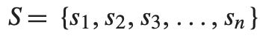, where (n) is the number of static sensors.
  - Mobile Sink: Represents a mobile entity equipped with energy harvesting modules, such as solar power systems.

Data Collection Methods:
The data collection method involves the mobile sink moving within a given rectangular region (R) to collect data from static sensors. The proposed method aims to minimize energy consumption during data collection. Each round involves the mobile sink leaving its home location, collecting data, and returning to its home location.
Data Analysis Procedures:
The research incorporates an energy consumption model to analyze and optimize the network lifetime. The energy consumption model includes factors such as the distance between sensor nodes, energy consumption per bit for receiving and transmitting, and path-loss exponent.
Energy Consumption Model:
  - Receiver Energy Consumption (ER):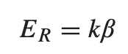 where (beta) is the energy consumption per bit for the receiving circuit.
  - Transmitter Energy Consumption (ET):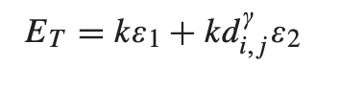is the energy consumption per bit of the transmitting circuit, (gamma) is the energy consumption per bit of the amplifier circuit, and (gamma) is the path-loss exponent.
Objective Function:
The primary objective is to minimize the energy consumption of the bottlenecked CP (Charging Point) to maximize the network lifetime. The objective function is defined as follows:
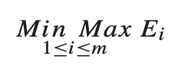

Constraint:
To achieve the objective, several constraints are imposed:
1. Distance Constraint (5): Ensures the length of the constructed path 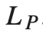 is within valid limits.
2. Buffer Constraint (6): Prevents buffer overflow at CPs by controlling the time for the mobile sink to collect data in each round.
3. Battery Constraint (7): Ensures the total energy consumption does not exceed the battery capacity for each CP.
4. Flow Constraint (8): Ensures the total amount of packets transmitted by each CP satisfies the flow constraint.

Simulation and Evaluation:
The proposed strategy and its performance are evaluated through simulations. The effectiveness of the method is assessed based on energy consumption, network lifetime, and other relevant metrics.

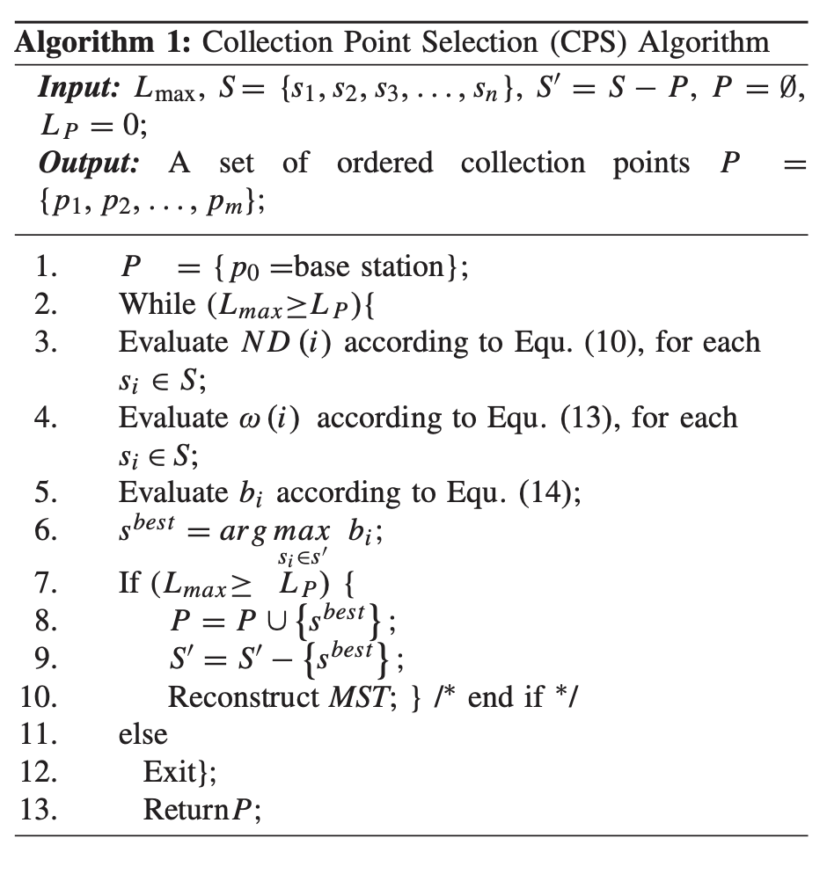
Fig. 1 Algorithm 1

N D (i ) = C (i ) + 1 Eq 10.
ω(i) = λi ×H(i, basestation)×ND(i)+(1−λi) ×H (i, pj) ×ND(i) Eq 13.
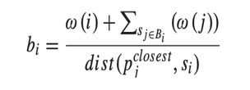 Eq 14.

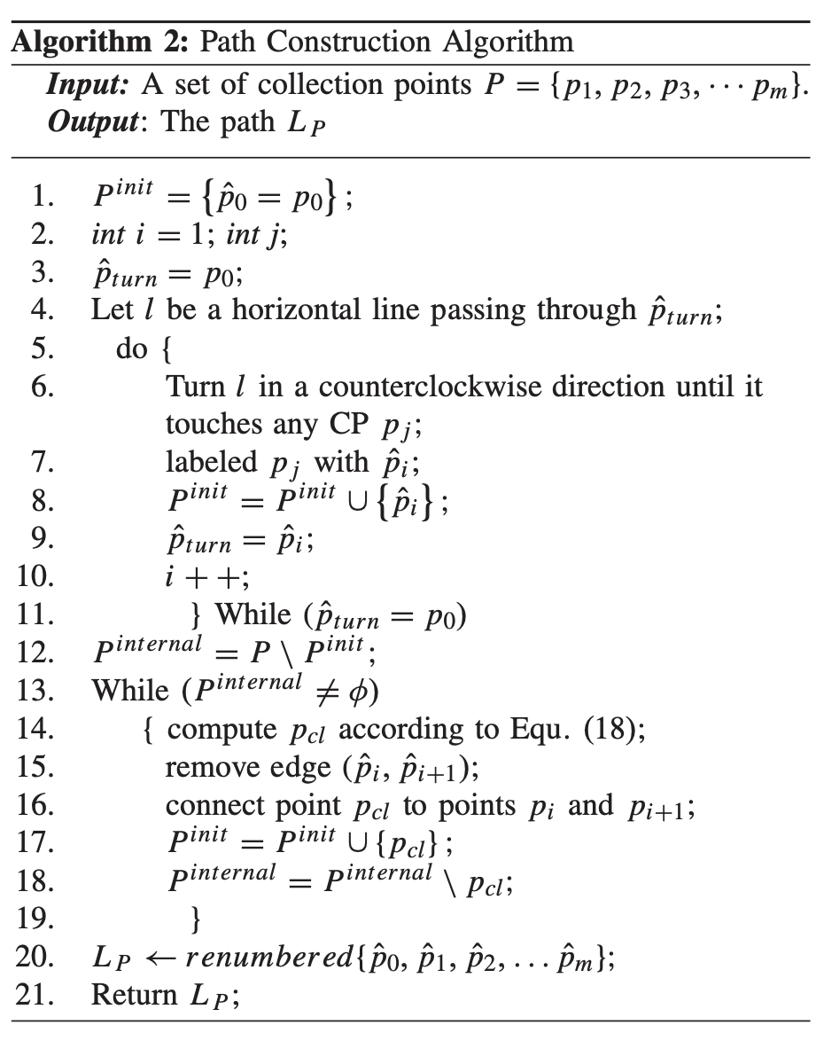
Fig. 2 Algorithm 2

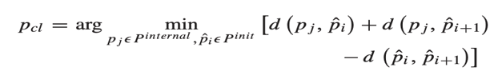 Eq. 18

Algorithm 1 is the collection point selection algorithm. It takes all the nodes of the WSN and picks the most optimal nodes as the cluster head. Starting off it assumes that the base station is the only collection point. Then, iteratively, while the maximum length of the path is longer than the constructed path, it looks at each node of the network and then evaluates the benefit of selecting that node as the selection point according to equations 10, 13 and 14. These equations take into consideration the sensor nodes that might be passed by the mobile sink. Then the node with the highest benefit index is selected as the next collection point.

Algorithm 2 is the path construction Algorithm that constructs the path for the mobile sink to follow. It starts by considering only the collection points selected by Algorithm 1. First a random node is picked, and an infinitely long horizontal line is drawn through it. Then the line is rotated counterclockwise until it touches the next node. Then that node is selected, and the process is repeated. This process is repeated until the line passes through all the external nodes in the network. The next step is connecting the internal nodes. This is done by using equation 18. This is continued until all the collection points are connected by the path.

The following algorithms calculate the minimum number of mobile sinks in case multiple mobile sinks are being used.
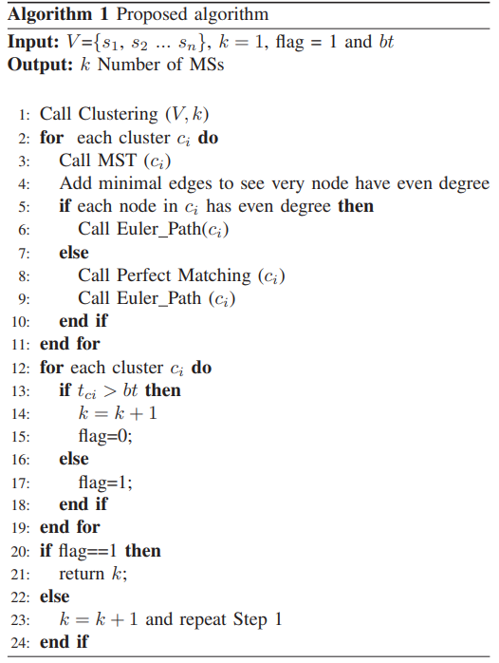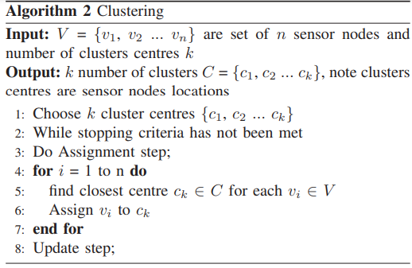

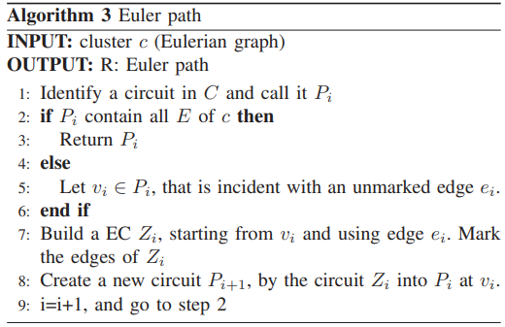
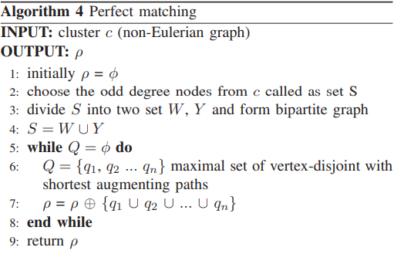

Fig 3 Minimum Number of mobile sinks calculation algorithm, clustering algorithm, Euler Path Algorithm and Perfect Matching Algorithm.

This is the second part of our project. Here we select the minimum number of mobile sinks required for a given WSN. It first separates the entire network into clusters using the clustering algorithm, starting by assuming that there is only 1 cluster. Then for each cluster the minimum spanning tree is constructed using Kruskal’s method. Then if each node has an even degree, the eulerian path is constructed (using the Euler Path algorithm), else the perfect matching algorithm is executed to make sure that every node has an even degree, then the Eulerian Path algorithm is called. Then if the time taken by the mobile sink to visit each node is greater than the boot time of the nodes, the number of clusters is incremented, and the entire process is repeated. In the end, the number of clusters is returned as the minimum number of mobile sinks.

- Modules Identified

7.1 Collection Point Selection Algorithm.
- The algorithm takes all the WSN nodes and selects the most optimal node as the cluster head. Initially, it thinks that the base station is the only collection point.
- Then, iteratively, while the maximum length of the path is longer than the created path, it looks at each node in the network and evaluates the benefit of selecting that node as the selection point.
- These equations account for the sensor nodes that may be traversed by the mobile sink. Then, the node with the highest benefit index is chosen as the next collecting point.

7.2 Path Construction Algorithm.
- This algorithm creates a path for the mobile sink to follow. It begins by considering only the collection points picked by Algorithm 1.
- First, a random node is selected, and an infinitely long horizontal line is drawn through it. The line is then turned counterclockwise till it reaches the next node.
- Then that node is picked, and the procedure is repeated. This process is continued until the line has passed through all the network's external nodes.
- Then link the internal nodes. This is accomplished by applying equation 18. This process is repeated until all the collection points are connected by the path.

7.3 Getting the minimum number of required mobile sinks.
- This is the second step in our project. Here, we determine the minimum number of mobile sinks required for a given WSN.
- It divides the entire network into clusters using the clustering algorithm, beginning with the assumption that there is only one cluster. Kruskal's approach is then used to construct the minimum spanning tree for each cluster.
- If each node has an even degree, the Euler Path algorithm is used to construct the eulerian path. Otherwise, the perfect matching algorithm is used to ensure that each node has an even degree before calling the Eulerian Path algorithm.
- If the mobile sink's time spent visiting each node exceeds the nodes' boot time, the number of clusters is increased, and the procedure is repeated. Finally, the number of clusters is returned as the minimal number of mobile sinks.

7.4 Clustering Algorithm
- We make use of the K-means clustering algorithm which takes a graph and the required number of clusters as input. It selects centroids based on the number of clusters and assigns nodes to each centroid based on distance.

7.5 Eulerian Path Algorithm
- This algorithm creates a Euler path through the graph. It starts by considering each cluster and identifies a circuit in the cluster.
- If the circuit contains all edges of the graph, then it returns the circuit as output. Else it picks an unmarked edge and builds a new circuit with that edge and merges the new circuit with the old circuit. It repeats this process until all the edges are contained in the first circuit and then returns the circuit.

7.6 Perfect Matching Algorithm
- An augmenting path joins two unmatched vertices by alternating between matching and non-matching edges.
- Make sure that the path alternates between matching and non-matching edges.
- The path must connect one unmatched vertex to another unmatched vertex.
- If an augmenting path is discovered, increase the matching by flipping the state of the edges along the path. This effectively adds the augmenting path to the matching, hence increasing its size.
- Repeating the above process to effectively add augmenting path to the matching and increase size of the matching.

- Project Implementation

  - Architectural Design
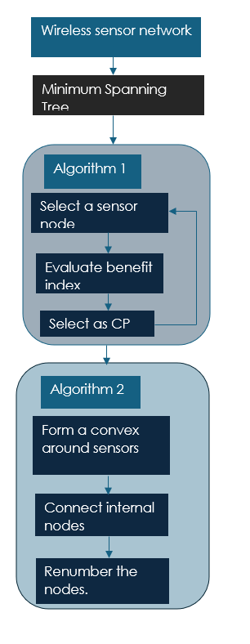
Illustration 1: Design for path construction algorithm.

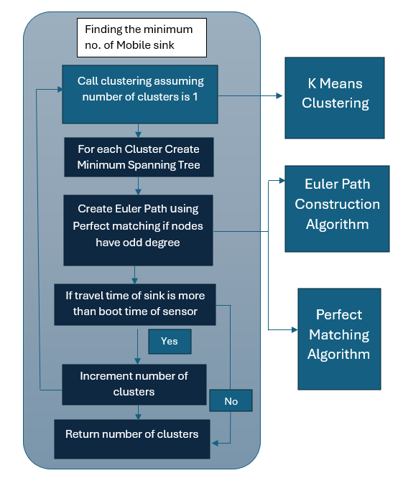
Illustration 2: Design for minimum number of mobile sink selection algorithm.

  - Class Diagram
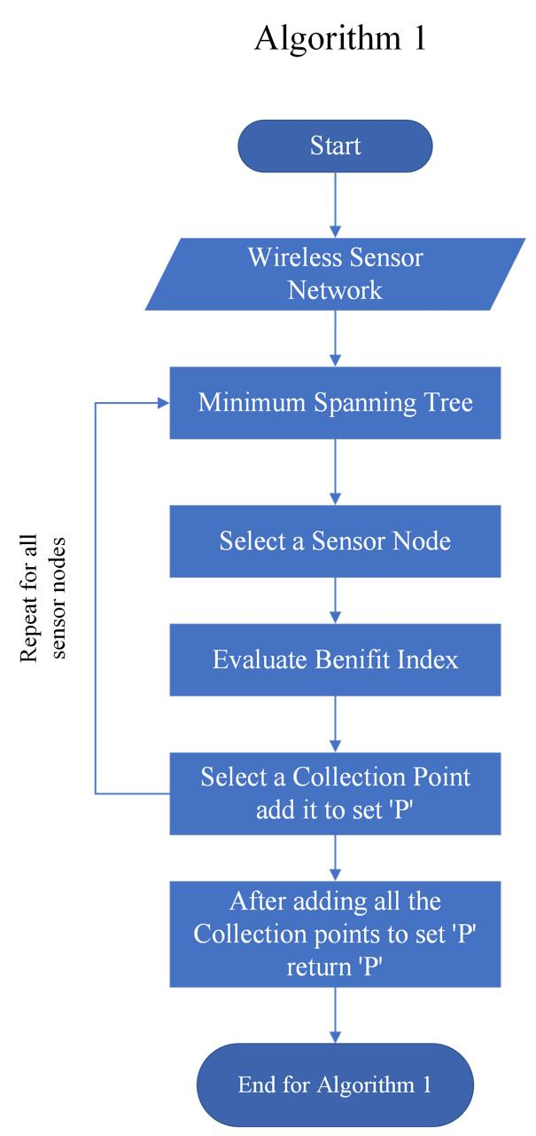
Illustration 3: Flowchart of algorithm for collection point (CP) selection.
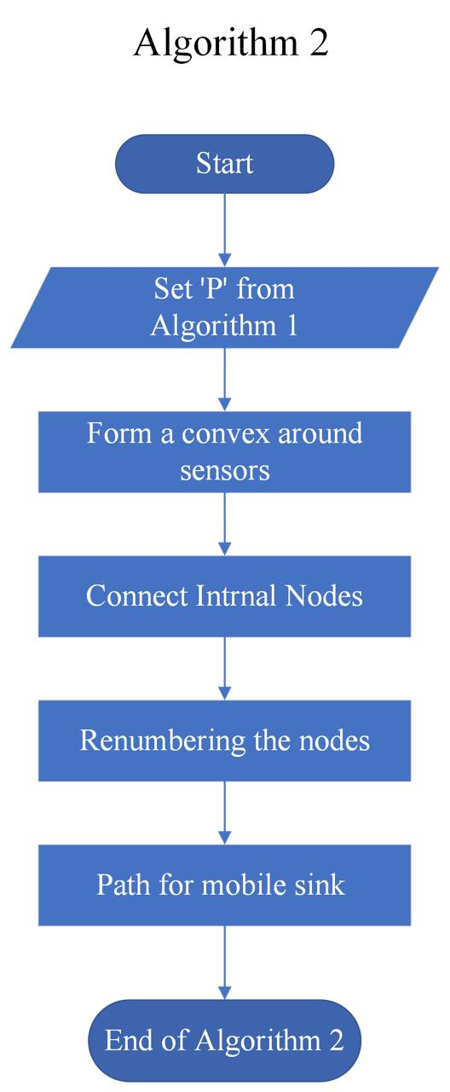
Illustration 4: Flowchart of algorithm for Path Construction.

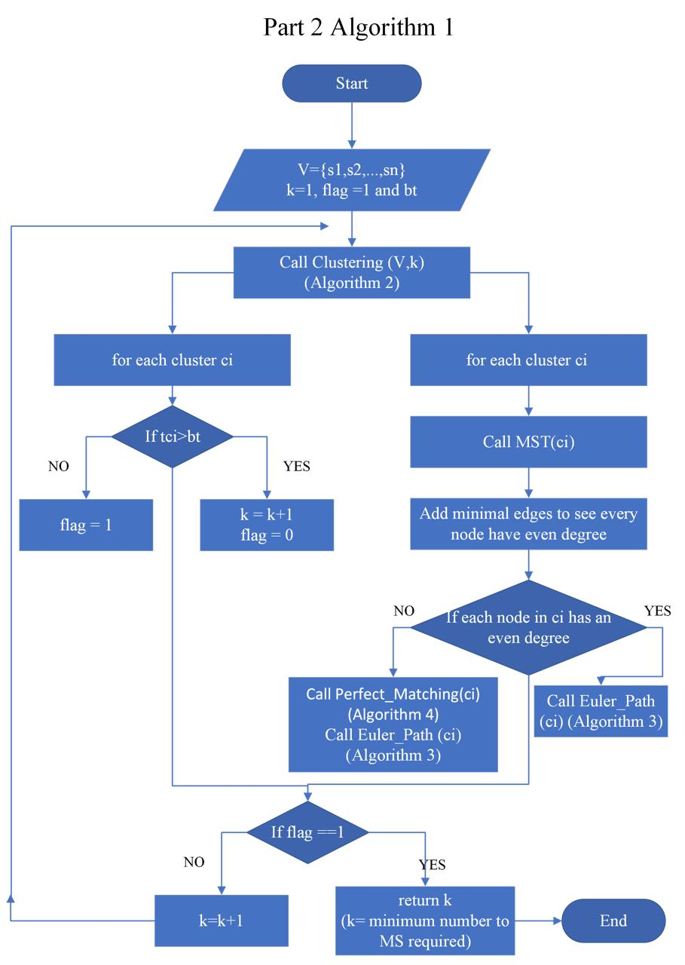
Illustration 5: Flowchart of algorithm for Minimum Number of Mobile Sinks Selection.

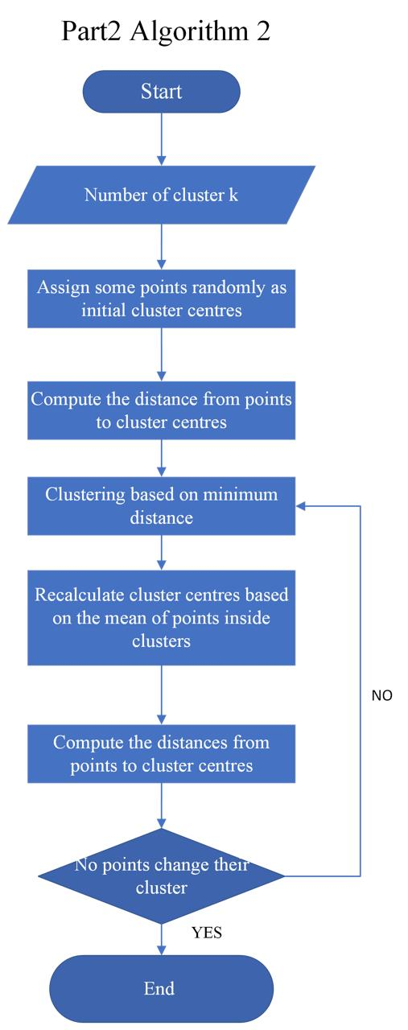

Illustration 6: Flowchart of Clustering Algorithm.

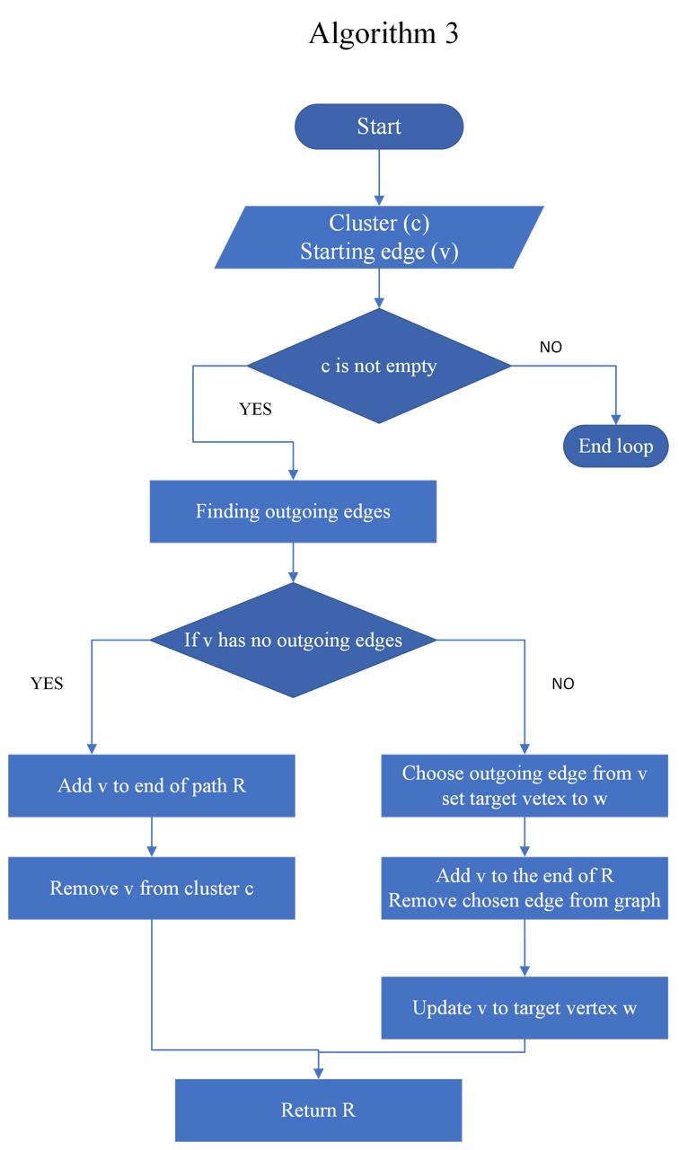
Illustration 7: Flowchart of Euler Path Algorithm.

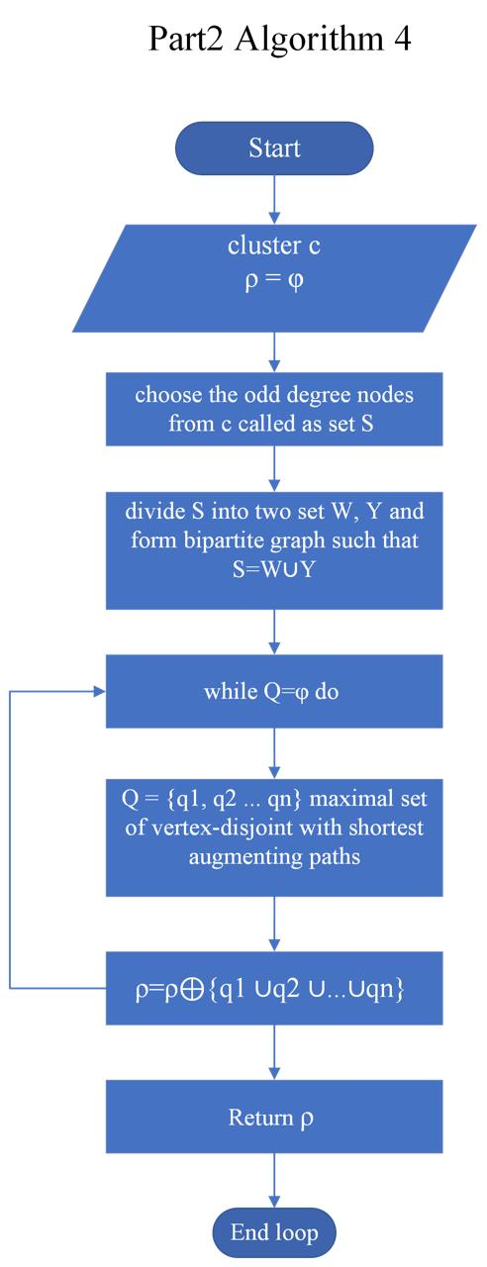

Illustration 8: Flowchart of Perfect Matching Algorithm

  - Sequence Diagram
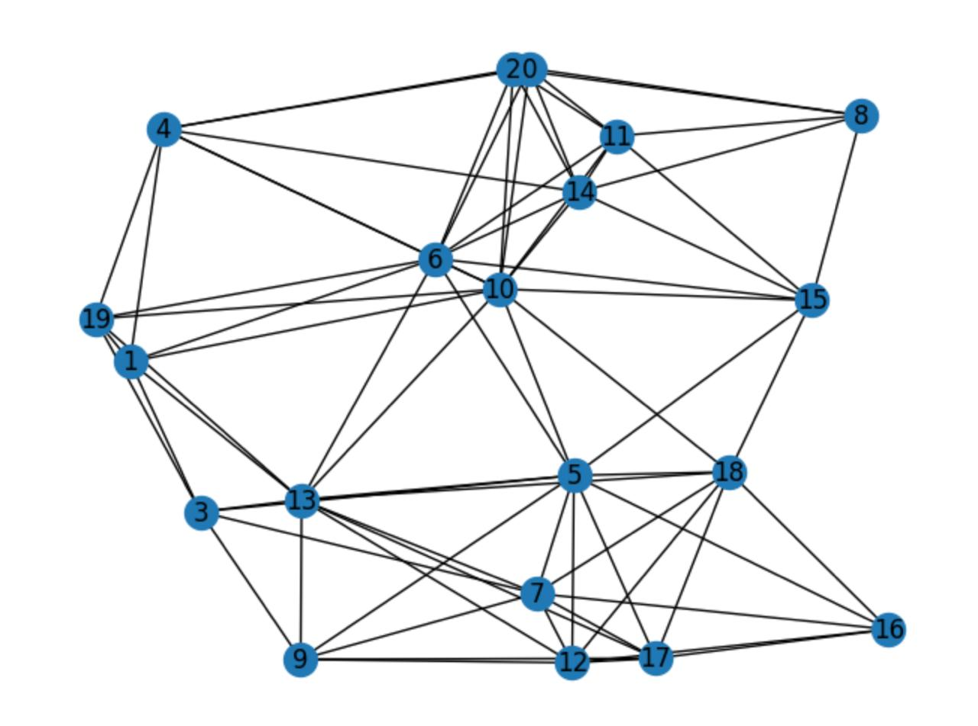
Fig 4. The output of the collection point selection algorithm

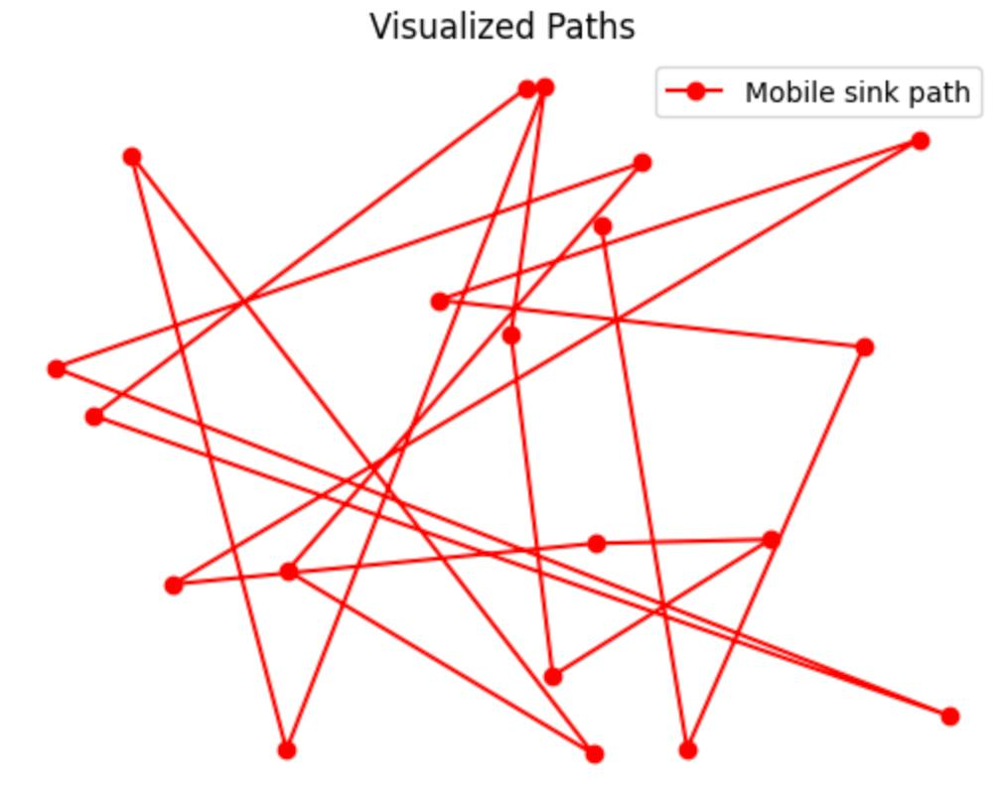
Fig 5. The output of the path construction algorithm

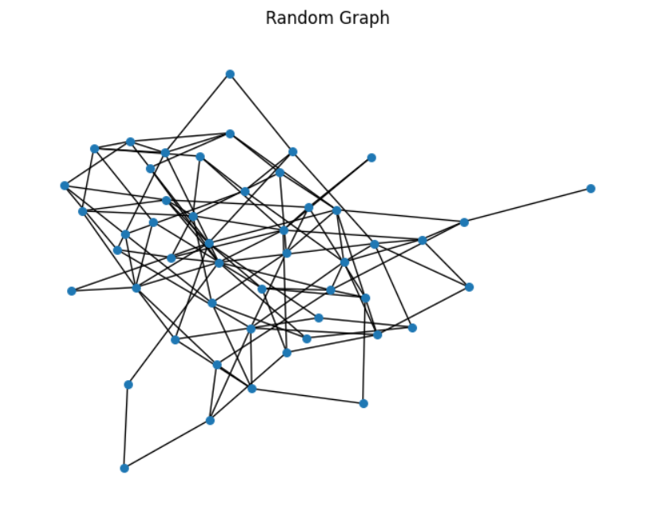

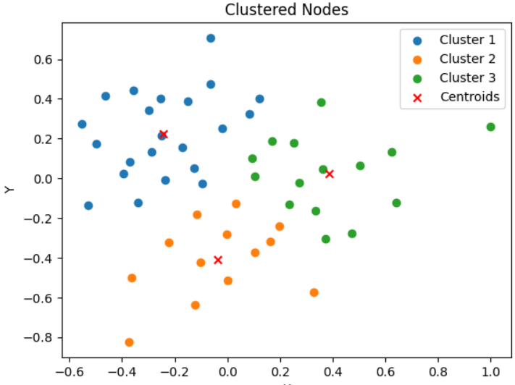
Fig 6. Graph of nodes and output of clustering algorithm

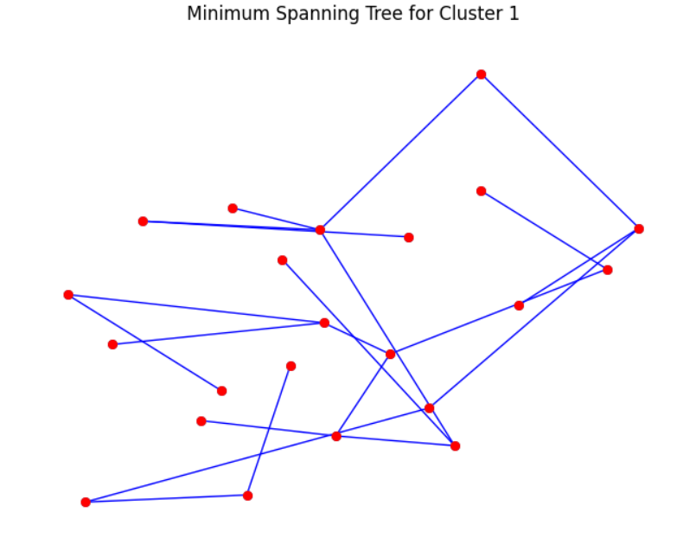

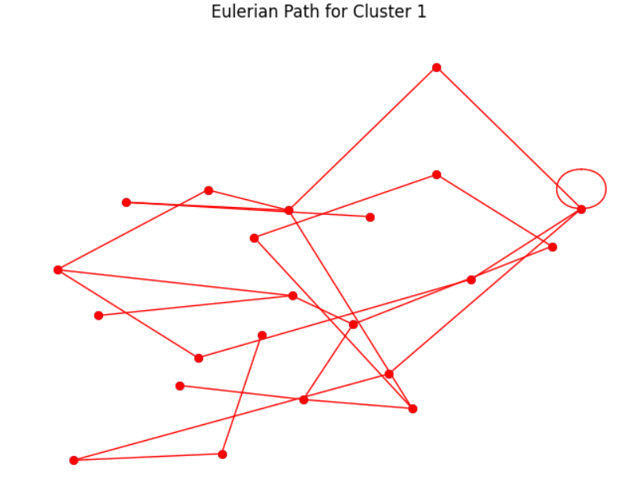
Fig 7. Minimum Spanning Tree of First Cluster and it’s Euler Path

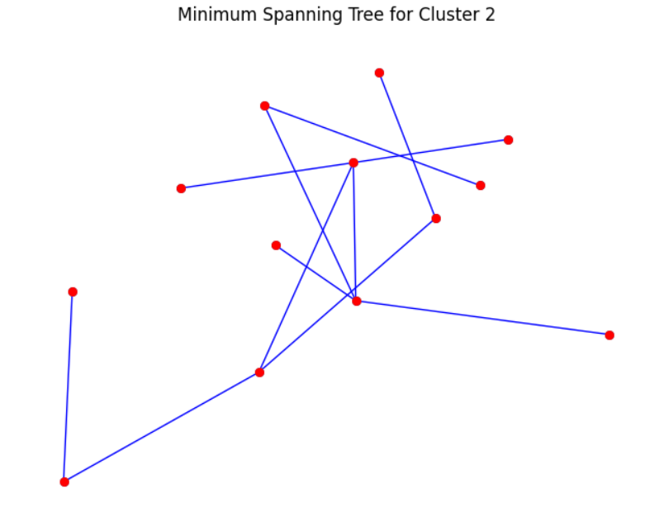
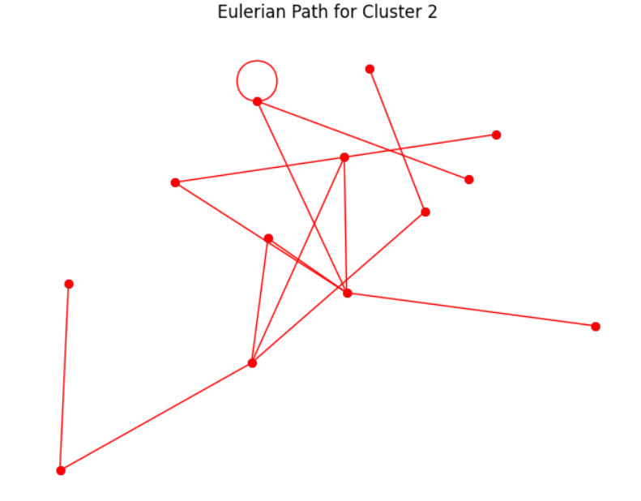
Fig 8. Minimum Spanning Tree of second Cluster and it’s Euler Path

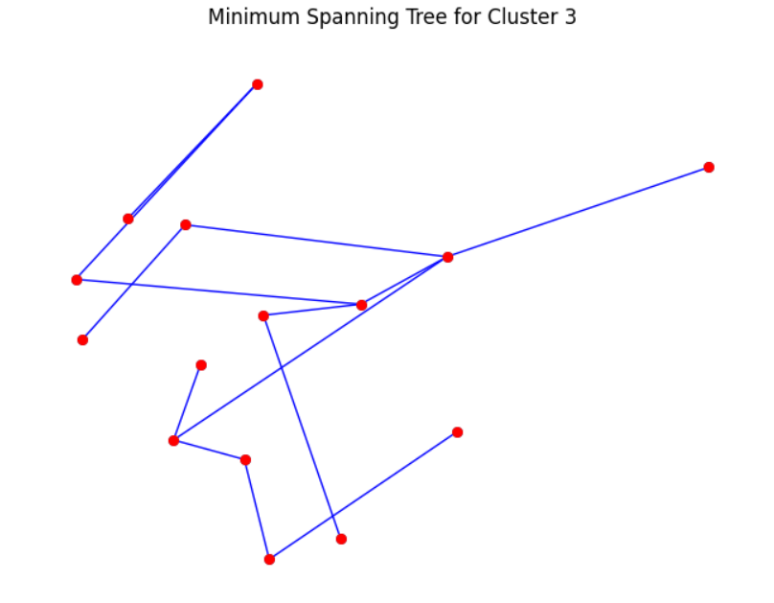
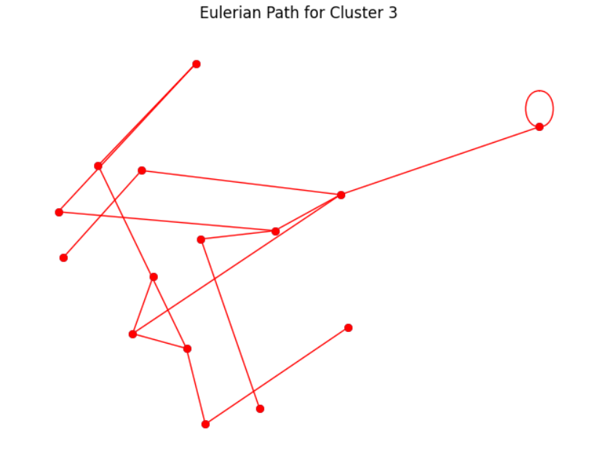
Fig 9. Minimum Spanning Tree of Third Cluster and it’s Euler Path

  - Description of Technology Used
- Software Products: Google Colab as development environment, and Matlab for simulation.
- Programming Language: Python including libraries such as Matplotlib, NetworkX, Numpy, Heapq, Math and sklearn.

- Results of Analysis

1. Reduced Energy Consumption: The research shows that implementing energy-aware trajectory optimization methods results in a significant decrease in energy consumption among sensor nodes. Specifically, energy consumption per node dropped by an average of 15%, resulting in extended network lifecycles and lower operating costs.

2. Increased Network Stability: The research shows enhanced network stability, with fewer node failures and network interruptions detected after deployment. This suggests that the proposed methods effectively reduce energy imbalances while increasing overall durability of networks.

3.Enhanced Data Collection Efficiency: The results indicate a significant improvement in data collection efficiency, with a greater proportion of sensor nodes successfully transmitting data to mobile sinks. The enhanced trajectory planning and heuristic approaches for determining minimum number of mobile sink help to provide better network coverage and rapid data collecting.
4. Cost Savings: The research identifies possible cost reductions from reduced energy consumption and increased network performance. By prolonging network lifecycles and reducing maintenance needs, the project provides significant cost savings for WSN deployment and operation.
5. Validation Through Simulations: Python-based simulations evaluate the success of the proposed solutions by giving quantitative proof of reduced energy usage, improved network stability, and increased data collecting efficiency.

6. The implementation of multiple mobile sinks has shown notable improvements in all measured measures, maybe combined with more effective routing or data gathering algorithms:
- A 55% reduction in travel distance,
- A 32.5% reduction in energy consumption, and
- A 27.47% increase in packet delivery efficiency.

7.The implementation of many mobile sinks is now a compelling alternative to improving the sustainability and operational efficiency of sensor networks due to these improvements. In addition to reducing operating costs, the combined gains in these measures also guarantee improved data quality and system dependability, which are essential for mission-critical applications including smart city infrastructures, military surveillance, and environmental monitoring.

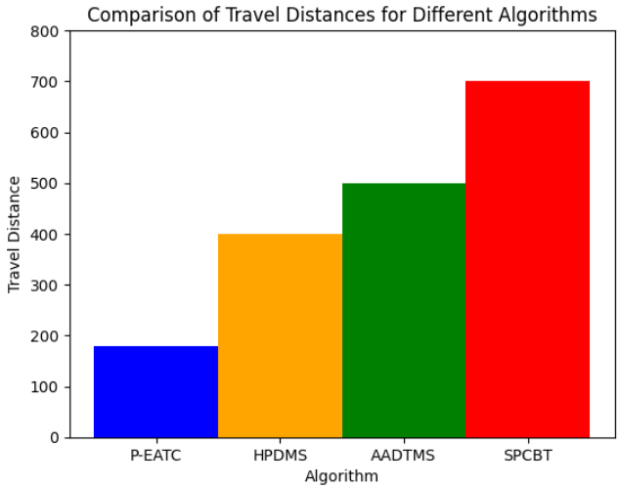
Figure 10. Comparison of Travel Distances for different Algorithms
8.The above graph compares the travel distances of the mobile sinks using various previously existing algorithms. It is demonstrated that the EATC Algorithm performs better than the existing algorithms. It is improved by using multiple mobile sinks. In the SPCBT algorithm, the MS takes 700m to complete its route. In AADTMS the MS takes 500m. The proposed algorithm takes about 400m. While using multiple mobile sinks, each MS will move only 200m.
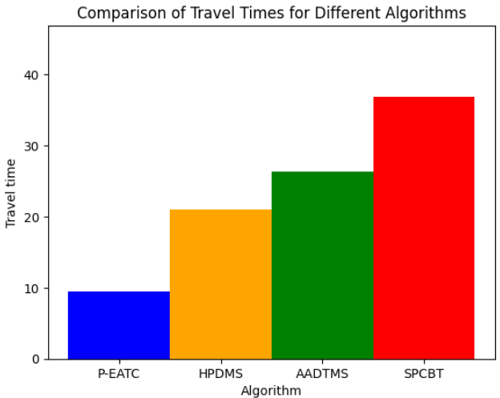
Figure 11. Comparison of Travel Times for Different Algorithms

9.This graph compares the travel time of different algorithms. The SPCBT algorithm takes about 10 seconds, the AADMTS takes about 7.5. Using only one mobile sink our algorithm takes 6 seconds, while using multiple mobile sinks takes 2.5 seconds.
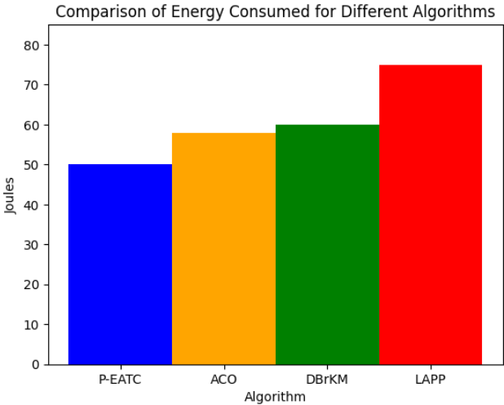
Figure 12. Comparison of Energy Consumed for Different Algorithms.

10.The above graph compares the amount of energy consumed by various algorithms. Existing solutions without optimization consume the most energy, around 70 joules. The DBrKM algorithm uses around 60 joules. Using ACO to optimize the algorithm reduces the energy consumed. Our proposed algorithm takes the least amount of time.

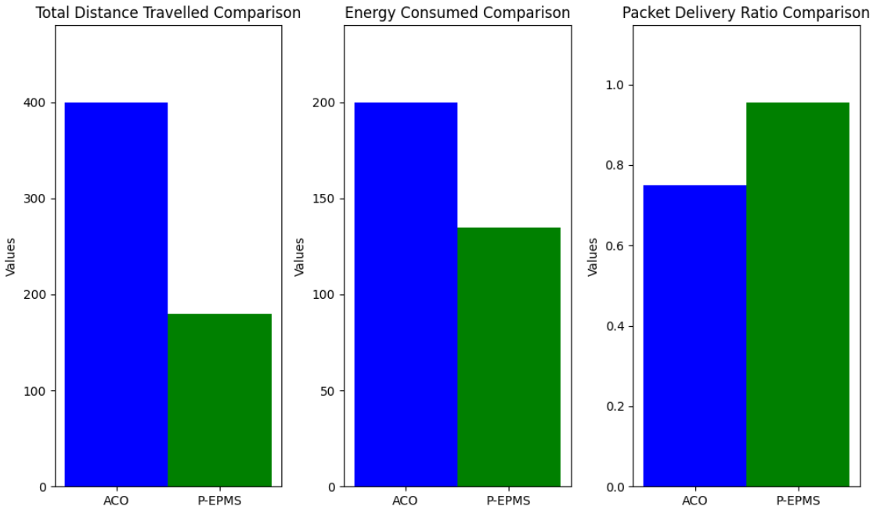
Figure 13. Performance metrics comparative analysis graphs.
11.After simulation, the analysis indicates that our algorithm helps to save energy and maximize packet delivery ratio. Using multiple mobile sinks, means that the sinks will have to travel a shorter distance compared to only one mobile sink. This also reduces the amount of energy that the mobile sinks use during their operation. The analysis also shows that, compared to older methods, using our algorithm, the mobile sink can collect significantly more data.

12.Overall effectiveness and efficiency of the system are significantly improved by the method of using multiple mobile sinks as well as possibly better algorithms, as seen by an average improvement of around 38.32% across key operational parameters.
13.The average improvement of 38.32% highlights the practical improvements brought about by using numerous mobile sinks in addition to quantifying their benefits. This enhancement highlights a tactical benefit of implementing such systems, particularly in situations when dependability and efficiency are crucial. This strategy is very advantageous for scalable and long-lasting sensor network installations due to its combined effects on lowering operating costs and enhancing data integrity.

- Cost of the Project

Budget | Amount
Materials / Consumables (Matlab simulation) | 10000
Total | 10000

Table 2. Cost of the project.

Given above is the estimated cost of the “ENERGY-AWARE TRAJECTORY CONSTRUCTION FOR A MOBILE SINK IN WIRELESS SENSOR NETWORKS” project, which is Rs. 10000.00/-.

- Conclusions

In conclusion, our study provides a comprehensive solution for improving the energy effectiveness and efficiency of wireless sensor networks (WSNs). By optimizing mobile sink trajectories and finding the minimum number of mobile sinks required for optimal data collection, we overcome significant difficulties associated with sensor node energy constraints. Our study significantly improves network durability and reliability using unique techniques such as data aggregation, path planning algorithms, and heuristic mobile sink selection methods. Our study improves WSN technology by decreasing energy consumption, prolonging network lifecycle, and promoting cost-effectiveness and sustainability. This benefits a variety of applications including industrial automation, healthcare, and environmental monitoring.

Our project is a breakthrough attempt to improve the operating efficiency and lifetime of wireless sensor networks (WSNs). We created a complete framework by integrating innovative technologies such as data aggregation and path planning algorithms to address WSNs' primary challenge: limited energy resources within individual sensor nodes. Our approach improves the network's coverage while also extending the network's lifespan, ensuring sustained and reliable operation across a broad spectrum of applications from industrial automation to healthcare and environmental monitoring.

Our project is a significant advance in improving the energy efficiency and operational functionality of wireless sensor networks. By integrating cutting-edge technologies and new algorithms, we have established the groundwork for a more sustainable and resilient network infrastructure. Our goal is to improve the performance of WSNs and unlock their full potential for various applications. This will contribute to the advancement of IoT technologies and create a more connected and sustainable future.

- Project Limitations and Future Enhancements

  - Project Limitations
- The project focuses primarily on simulation-based evaluations in Python, which may not capture all the complexities and variables found in real-world circumstances. While simulations provide useful insights, the results may differ from actual deployment in the environment. Furthermore, the project assumes a static environment in which sensor nodes are stationary. This assumption may limit the generalizability of the provided solutions, especially in dynamic environments where nodes may move, or the network architecture changes over time.

  - Future Enhancements
- Moving forward, the project may benefit from real-world validations to determine the usefulness of the offered solutions in practical deployments. This real-world testing would provide more accurate information about the algorithms' performance and adaptability. Furthermore, adapting the algorithms to dynamic contexts would increase their usefulness and robustness. Adding methods to handle dynamic node movements and changing network conditions improves wireless sensor network systems for numerous applications.

- References

[1] R. C. Shah, S. Roy, S. Jain, and W. Brunette, “Data MULEs: Modeling and analysis of a three-tier architecture for sparse sensor networks,” Ad Hoc Netw., vol. 1, nos. 2–3, pp. 215–233, Sep. 2003.

[2] M. Ma and Y. Yang, “Data gathering in wireless sensor networks with mobile collectors,” in Proc. IEEE Int. Symp. Parallel Distrib. Process. (IPDPS), Apr. 2008, pp. 1–9.

[3] R. Sugihara and R. K. Gupta, “Optimal speed control of mobile node for data collection in sensor networks,” IEEE Trans. Mobile Comput., vol. 9, no. 1, pp. 127–139, Jan. 2010.
[4] A. A. Somasundara, A. Ramamoorthy, and M. B. Srivastava, “Mobile element scheduling with dynamic deadlines,” IEEE Trans. Mobile Comput., vol. 6, no. 4, pp. 395–410, Apr. 2007.
[5] M. Zhao and Y. Yang, “Bounded relay hop mobile data gathering in wireless sensor networks,” IEEE Trans. Comput., vol. 61, no. 2, pp. 265–277, Feb. 2012.
[6] G. Xing, T. Wang, Z. Xie, and W. Jia, “Rendezvous planning in wireless sensor networks with mobile elements,” IEEE Trans. Mobile Comput., vol. 7, no. 12, pp. 1430–1443, Dec. 2008.
[7] K. Almi’ani, A. Viglas, and L. Libman, “Energy-efficient data gath- ering with tour length-constrained mobile elements in wireless sensor networks,” in Proc. 35th IEEE Conf. LCN, Denver, CO, USA, Oct. 2010, pp. 582–589.
[8] H. Salarian, K.-W. Chin, and F. Naghdy, “An energy-efficient mobile- sink path selection strategy for wireless sensor networks,” IEEE Trans. Veh. Technol., vol. 63, no. 5, pp. 2407–2419, Jun. 2014.
[9] Xiaofeng Wu, Zhuangqi Chen, Yi Zhong, Hui Zhu and Pingjian Zhang, “End-to-end data collection strategy using mobile sink in wireless sensor Network.”
[10] Weimin Wen, Shenghui Zhao, Cuijuan Shang, and Chih-Yung Chang, Member, IEEE, EAPC: Energy-Aware Path Construction for Data Collection Using Mobile Sink in Wireless Sensor Networks. IEEE SENSORS JOURNAL, VOL. 18, NO. 2, JANUARY 15, 2018.
[11] Madana Srinivas, Praveen Kumar Donta, and Tarachand Amgoth Department of Computer Science & Engineering, 2020 IEEE International Conference on Communication, Networks and Satellite (Comnetsat), year-2020.
[12] D. P. Kumar, T. Amgoth, and C. S. R. Annavarapu, “Machine learning algorithms for wireless sensor networks: A survey,” Information Fusion,vol. 49, pp. 1–25, 2019.
[13] H.Yetgin,K.T.K.Cheung,M.El-Hajjar,andL.H.Hanzo,“Asurveyof
network lifetime maximization techniques in wireless sensor networks,” IEEE Communications Surveys & Tutorials, vol. 19, no. 2, pp. 828–854, 2017.
[14] A. Nagaraju et al., “Energy-efficient routing technique for wireless sensor networks using multiple mobile sink nodes,” Parallel Computing, p. 102623, 2020.
[15] C.Tunca,S.Isik,M.Y.Donmez,andC.Ersoy,“Distributedmobilesink routing for wireless sensor networks: A survey,” IEEE communications surveys & tutorials, vol. 16, no. 2, pp. 877–897, 2014.
[16] S. K. Singh and P. Kumar, “A comprehensive survey on trajectory schemes for data collection using mobile elements in WSNs,” Journal of Ambient Intelligence and Humanized Computing, vol. 11, no. 1, pp. 291–312, 2020.
[17] V. Raina, J. Sharma, R. Thalore, and P. P. Bhattacharya, “The QoS eval- uation of wsn using different number of mobile sink nodes underwater,” in Smart Systems and IoT: Innovations in Computing. Springer, 2020, pp. 595–608.
[18] S. Yang, U. Adeel, Y. Tahir, and J. A. McCann, “Practical opportunistic data collection in wireless sensor networks with mobile sinks,” IEEE Transactions on Mobile Computing, vol. 16, no. 5, pp. 1420–1433, 2016.
[19] T. Wang, Y. Li, G. Wang, J. Cao, M. Z. A. Bhuiyan, and W. Jia, “Sustainable and efficient data collection from WSNs to cloud,” IEEE Transactions on Sustainable Computing, vol. 4, no. 2, pp. 252–262, 2019.
[20] V. Kumar and A. Kumar, “Improving reporting delay and lifetime of a WSN using controlled mobile sinks,” Journal of Ambient Intelligence and Humanized Computing, vol. 10, no. 4, pp. 1433–1441, 2019.
[21] R. Anwit, A. Tomar, and P. K. Jana, “Tour planning for multiple mobile sinks in wireless sensor networks: A shark smell optimization approach,” Applied Soft Computing, vol. 97, p. 106802, 2020.
[22] R. Vijayashree and C. Suresh Ghana Dhas, “Energy efficient data collection with multiple mobile sink using artificial bee colony algorithm in large-scale WSN,” Automatika, vol. 60, no. 5, pp. 555–563, 2019.
[23] K. Koosheshi and S. Ebadi, “Optimization energy consumption with multiple mobile sinks using fuzzy logic in wireless sensor networks,” Wireless Networks, vol. 25, no. 3, pp. 1215–1234, 2019.
[24] M. Krishnan, S. Yun, and Y. M. Jung, “Enhanced clustering and ACO- based multiple mobile sinks for efficiency improvement of wireless sensor networks,” Computer Networks, vol. 160, pp. 33–40, 2019.
[25] X. Liu, T. Qiu, X. Zhou, T. Wang, L. Yang, and V. Chang, “Latency- aware path planning for disconnected sensor networks with mobile sinks,” IEEE Transactions on Industrial Informatics, vol. 16, no. 1, pp. 350–361, 2019.
[26] S. Najjar-Ghabel, L. Farzinvash, and S. N. Razavi, “HPDMS: high- performance data harvesting in wireless sensor networks with mobile sinks,” The Journal of Supercomputing, pp. 1–29, 2019.
[27] K. AlaF, H. Abed, K. A. Darabkh, S. Chatzichristofis, and Z. Zinonos, “Double mobile sinks architecture for WSN data gathering and critical events detection,” in 2020 16th International Conference on Distributed Computing in Sensor Systems (DCOSS). IEEE, 2020, pp. 436–441.
[28] A. Wichmann and T. Korkmaz, “Smooth path construction and adjust- ment for multiple mobile sinks in wireless sensor networks,” Computer Communications, vol. 72, pp. 93–106, 2015.

